User Interface Programming – Project Research Workbook

This workbook will help you focus your research for your project.
Once you have answered these questions, use this information in your GUI Design Document.

Briefly describe the application or game you will design and create the user interface for.

The graphical user interface you design may be just a piece or sub-section of a larger application.
This is your initial idea to focus your research. The application described in your design document, or your final build, may end up being different from this description.

Keep in mind that you may want the project you develop in this subject to integrate with the project you create for the subject Cross-Platform Development.
I decided to integrate the project I created for the Cross-Platform Development task, which is a 3rd person platformer where you must make it across multiple levels collecting trophies without losing all your health in one. If you die, you restart the game.

Identify any industry best practices, standards, codes of practice, or similar requirements or frameworks that may be applicable to the graphical user interface you are designing.

You may want to consider developer guidelines for app or game stores, video game rating regulations, and industry best practice reflected in online blogs, guides, or conference recordings.

Describe the functionality of your GUI.

Use diagrams or mock-ups to detail the front-end interface (what the user sees).

Describe the events or processing that occurs in response to actions the user performs using the interface (i.e., the back-end processing).
The only GUI featured in the game will be for the HUD, which will show the player’s health, trophies collected in the current run and total amount of deaths.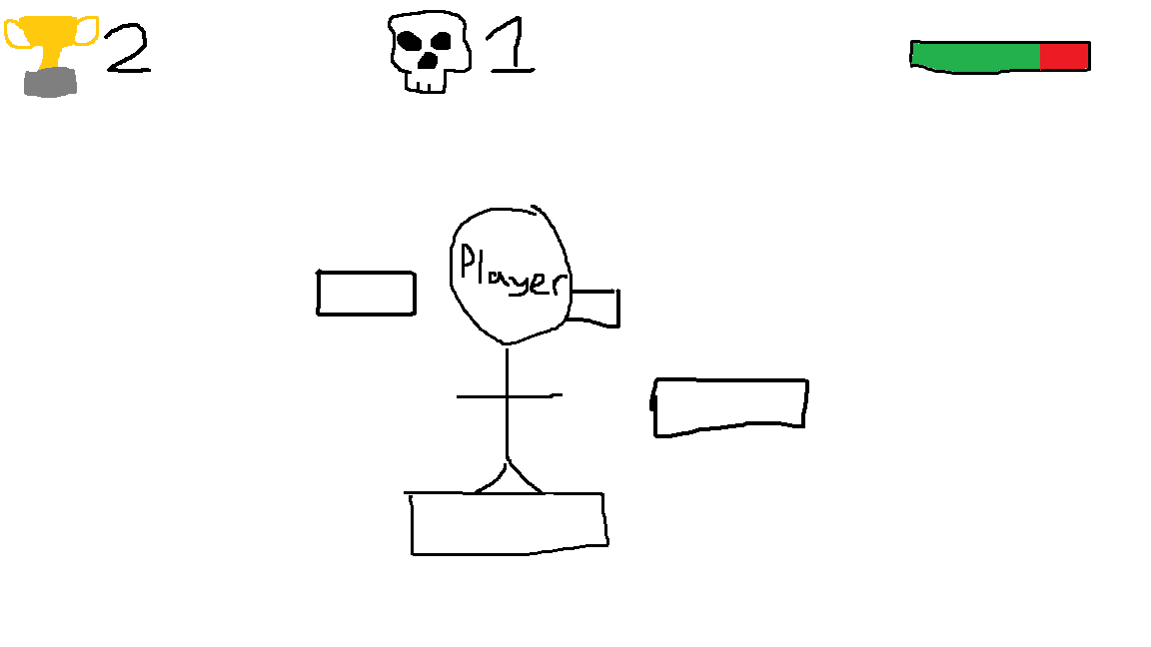

When the player falls and lands on spikes below the platforms, the health bar in the top right will go down a little bit.
When the player makes it to the end of the level and touches the gold trophy, the trophy count in the top left will increase by one, and the player will be transported to the next level, and their health will be reset.
When the player loses all their health, a death will be added to the death counter in the top middle of the screen, they will be transported back to the first level, and their trophy count and health will be reset.

What prototyping tools are available to you? Which one(s) will you use?

The prototyping tools available to me are just all the prebuilt assets already in unreal engine like the default classes and shapes. I plan to use the Cube and Cone assets that are in unreal engine to make simple spikes and platforms. I will use a sphere with a default gold texture in the place of an actual trophy asset.

What resources are required for the development of the user interface?
Include both software, and assets.

I’ll use the website drawio.com to create flowcharts for the functions for the UI, I’ll use Microsoft Paint to sketch what the UI will look like, and I’ll use Unreal Engine to create the UI itself, along with the functions for all the UI elements.

List and describe the information that is contained within a design document used to describe the design of a graphical user interface.

In how much detail is each piece of information typically described?

What diagrams may be included?

